Reviewer Note: Reviews for this pattern are due Sept 21st.
Also, FYI: Having planned to write this pattern as far back as January, the original name for this pattern was to be Client Proxy. However, since the Sun Java Center team has recently published this particular pattern under the name ‘Business Delegate’, I decided to keep the same name, in order to reduce confusion. If you have already read SJC’s excellent Business Delegate writeup, I would recommend reading this version as well, as it is distinct in content and pattern implementation, and presents different arguments for and against the pattern.

Business Delegate
When using Session and/or Message Façade, the client is tightly coupled to the EJB layer, creating dependencies between client and server that affect both development, run-time and project management concerns.
How can an intermediary between a client and the Session Façade be created to facilitate decoupling the client from the EJB layer?
In a good EJB design, use cases should be divided up over a layer of Session and/or Message Driven beans, as described in the Session and Message Façade patterns respectively. A common way to interact with this layer is via direct invocation from client code. That is, your presentation layer will directly interact with EJBHomes, and EJBObjects for Session Beans, and send JMS messages when talking to message driven beans.
Ironically, programming directly to the EJB API’s is not always the best way to program EJB applications. Various issues can arise, all of which revolve around the problems created by tightly coupling the client layer to the EJB layer:
Reduces separation of roles between client programmers and server programmers. On large projects, speed and efficient project completion depends upon the ability of the client tier (ie: servlet/JSP) developers and the server-side EJB developers to work independently. One common dependency that can arise between teams is the availability of the complete and compiled session bean layer. Client programmers depend on the implementation of the Session Façade in order to compile and test their code creating a terrible bottleneck between the two teams.
Places optimistic concurrency recovery responsibility on clients. Often a transaction will fail due to an optimistic concurrency conflict at the app. server or database level, catch-able by the client as TransactionRolledBackException or TransactionRolledBackLocalException. For certain types of use cases (such as idempotent operations), it may not be necessary to propagate this error down to the end application user and ask them to retry (usually by clicking submit again on a web form). Instead, client code should automatically re-execute the transaction. When coding directly to the EJB API’s, client code needs to be explicitly aware of catching these transactions and re-trying them, which places a large responsibility on the client developer as well as cluttering their code.
Complicates client logic with complex error handling. Clients need to be burdened with the ability to catch and react to the myriad number of errors that can occur when looking up and using EJBs including exceptions thrown when looking up components, RemoteExceptions, EJBException (when using Local Interfaces), etc. Remote or EJBExceptions in particular can occur for a variety of different reasons (such as optimistic concurrency conflicts described above), placing the responsibility on the client to implement messy code required to parse an exception and determine how to react to it.
Couples the clients directly to EJB and JMS API’s. Even when executing simple use cases, clients need to be loaded with EJB or JMS specific code required to discover, create, execute and recover from business logic implemented in the Session or Message Façade layers. This creates inconsistency in the client code (different types of business services explicity executed with very different API’s) and complicates even the simplest of use cases, resulting in lower maintainability as a whole.
Despite the performance and maintenance benefits of the Session/Message Façade patterns, using these layers explicitly from the clients creates a tight coupling that impacts project development and over all maintainability of client code.
Therefore,
Create a layer of Business Delegates: plain java classes that hide EJB API complexity by encapsulating code required to discover, delegate to and recover from invocations on the Session and Message Façade EJB layers.
A business delegate is a plain java class that serves as an intermediary between client and server. Clients locally invoke methods on the business delegate, which then usually delegate directly to a method with the same signature on the session façade, or populate a JMS message and send it off to the Message Façade.
Business delegates map one-to-one to session beans on the session facades and can be written to wrap multiple message driven beans. For example, consider a forum message board application. Here we could expose our use cases (postMessage, addReply, etc...) on a ForumServices session bean, or each use case could be asynchronously executed by using separate message driven beans. Figure X.1 illustrates how Business Delegates would map to both architectures.
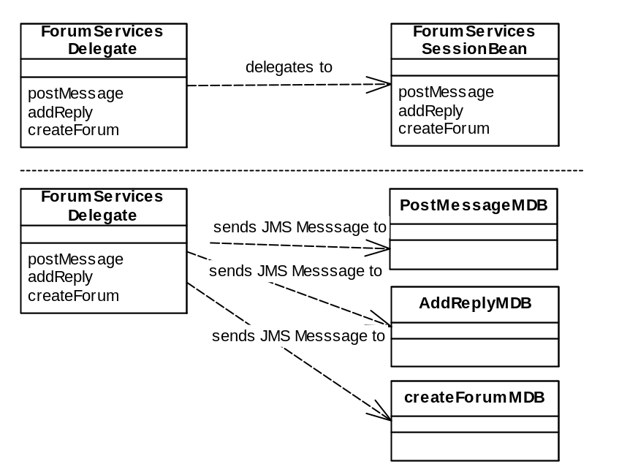
Figure X.1: Fronting Session/Message Façades with Business Delegates
In either case, the client code interacts only with the Business Delegate, oblivious to the API’s and processes being executed by the delegate itself. When a method is executed on a business delegate, it can perform the following functions:
Delegate method calls to an EJB. The delegate will take all the parameters passed in from the client and simply delegate this call to a method on the session façade, or pack the parameters into a JMS message and send them to a message driven bean.
Hide EJB specific system exceptions. API specific system exceptions such as RemoteException, EJBException or JMS exceptions are caught in the business delegate and re-thrown to the client as a non-ejb specific exceptions, such as a BusinessDelegateException. Application level exceptions are still passed to the client.
Cache data locally. A business delegate can cache the return results from a session bean method call locally and pass that out to clients on subsequent requests.
Transparently re-try failed transactions. Business delegates can implement the complicated error handling code required to determine the cause of a failed transaction (such as an optimistic concurrency conflict, described above), and re-try the transaction by re-executing the method on the session façade. Business delegates shield clients from this delicate, complicated process.
Execute business logic locally or create dummy data for clients. As mentioned in the first problem with coupling clients to EJB api’s, the client side project team is dependent on the existence of the session façade in-order to compile and test their code. Business Delegates provide a way for client programmers to write, compile and test working code without the existence of the session façade. Prototype business delegates can be written that simply return dummy data, or even execute business logic locally (good for quickly creating a working proto-type). As the server side EJB’s get built, the business delegate classes can be refactored to work with the EJB layer, all transparently to the client developers, who are no longer dependent on the EJB project team.

Implementing business delegates is simple. For every session bean in your application, simply create a local java class with the same method signature. Internally, the business delegate can perform any of the tasks outlined above, within its business methods. The only other piece of code that needs to be written is a constructor and a reference to the session bean that this delegate is fronting. In the delegate’s constructor, it should call an EJBHomeFactory (see the EJBHomeFactory pattern) to acquire a home for the session bean it represents and create an instance of the session bean, storing it locally as a member variable. On subsequent calls to business methods on the delegate, it should delegate these calls to the session bean reference stored internally, as in the following code:
public class ForumServicesDelegate
{
ForumServices sb;

public ForumServicesDelegate() throws DelegateException{
try{
PortalControllerHome home = (PortalControllerHome)
EJBHomeFactory.getFactory().lookUpHome
(PortalControllerHome.class, "ForumServices");

this.sb = home.create();
}catch(Exception e){
throw new DelegateException();
}
}

public long addForum(long categoryPK, String forumTitle, String summary, String imageName) throws NoSuchCategoryException,DelegateException {

try{
return sb.addForum( categoryPK, forumTitle, summary, imageName);
} catch(CreateException e){
throw new DelegateException();
} catch(RemoteException e){
throw new DelegateException();
}
}
… //more similarly implemented business methods

}//ForumServicesDelegate
For message driven beans, the business delegates are created to group similar use cases (that map to different message driven beans as in figure X.1), together in one class. Implementation is similar to that in the session bean example, except all methods return void.
The client view of a business delegate is simple. When a method needs to be executed, it simply creates a new delegate and calls a method on it. Behind the scenes, the business delegate initializes itself (using an EJBHomeFactory) in the constructor, and then delegates the method call. Since EJBHomes are cached in the EJBHomeFactory, creating and using a business delegate is relatively light-weight.
The only time when the semantics of using a business delegate change is when using them to front stateful session beans. In this case, a client does not create new business delegates upon every request, rather, it needs to create it once and then cache it locally, reusing the same delegate (which internally maintains a reference to the same stateful session bean). In a servlet application, delegates are cached in the ServletSession. One important benefit of using a business delegate to front a statefull session bean is that the class and its methods can be synchronized, which protects a client from making concurrent calls to the same statefull session bean (which is disallowed by the EJB spec, since EJBOBjects are not threadsafe). This problem can occur in websites that use frames (where each frame needs to make a request to the same stateful session bean), but is corrected transparently to the developer by using a Business Delegate.
When should the Business Delegate pattern be used? For projects in which the same developers are writing both the client and the server side code, the benefits of decoupling the client code from the server API’s may not be large enough to warrant the extra legwork in writing and maintaining this layer. However, for large projects where the web team is separate from the EJB team, business delegate can result in better decoupling between client and server side developers which can more than make up for the implementation work.

Related Patterns:
Business Delegate (SJC)

